Multimedia Product Critique Paper #1: Buzz Math
Tonya A. Melvin-Bryant
Coastal Carolina University

Multimedia Product Critique Paper #1: Buzz Math
Engaging learners in the 21st century is challenging, not only because of advances in thinking, but also because of the extreme strides made in technology. Younger learners of today are born into technology. Many, as young as 2 years old, are using a cell phone to watch videos and listen to music. How does traditional instruction (and learning) compete with this progress? One approach is to use newer technology in multimedia presentations. But what design principles will make this method meaningful to the learner? How should educators or instructional designers create instructional material so that retention occurs? This critique paper will review and provide a summary of an educational tool called Buzz Math that provides interactive and engaging instruction for math to middle school aged learners.
Buzz Math (http://www.buzzmath.com) is a website and mobile application developed by a collaborative of teachers, programmers, and designers based throughout the United States. It is designed for middle school students and focuses on learning and practicing math skills. Buzz Math requires Internet access, but can be used by parents and students at home, or on the go, not just by teachers at school. The instructional material is based on the NCTM (National Council of Teachers of Mathematics, http://www.nctm.org/) curriculum and Common Core State Standards, promoting mastery via detailed feedback that is provided immediately to the student. Missed attempts can be revisited by students since values used in the exercise are randomized, preventing students from just memorizing the answer. There are also built-in tools that allow teachers to follow student progress, but how meaningful is the learning for students? Are students able to activate prior knowledge to learn new concepts? Does pre-training of math names and characteristics need to happen before students can have meaningful learning of new material? In other words, how well does Buzz Math follow multimedia principles and learning theory?
Buzz Math requires a paid subscription but there is a demo classroom that I was able to create to test the website (https://www.buzzmath.com/activate, code: D4F9-8533). There is an easy to use teacher’s quick start guide provided (http://buzzmath-help.scolab.com/teacher-s-quick-start-guide). There is also an introductory video for parents to review content and how Buzz Math works (https://www.buzzmath.com/Families). I used the Interface Guide (http://buzzmath-help.scolab.com/interface-guide/activity) to obtain screenshots for this paper.
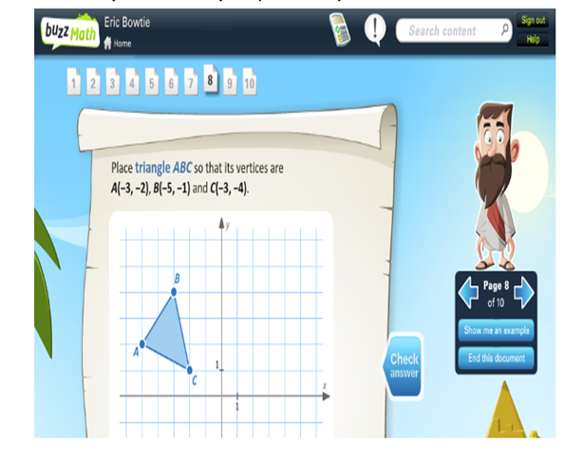
Figure 1. Activity with 10 pages
As can be seen in figure 1, Buzz Math allows students to pace themselves through the activity. The individual pages, usually 10, are located at the top of the activity. Arrows are located to the right of the page that will allow the student to traverse backwards and forwards through the pages as they learn the concept. Also shown is the page number out of the total pages and the student can view an example or end the document. The example will disallow rote learning as mentioned in Driscoll and cited from Ausubel et al. (1978), because the student can use the example to connect to prior knowledge. Rote learning is simply memorization, but by using this type of example, the student is shown the concept in context and even if the learner is low-knowledge, they are able to see the application and create new memory (Driscoll, 2005). This idea also improves upon the theory of schema as mentioned in Driscoll (2005). Schema represents generic concepts stored in memory (Driscoll, 2005, p. 129, as cited in Rumelhart, 1980, p. 34). The student does not have to infer information about an event (the event being the math concept), but can now see the actual event in action (application). There is an icon located on the page itself that will allow the student to check their answer, as seen in figure 3 below. This example follows the segmenting principle by allowing students self-paced the activity. According to Mayer (2014), the segmenting principle presents information in learner-paced segments rather than as a continuous unit (Mayer, 2014, p. 326).
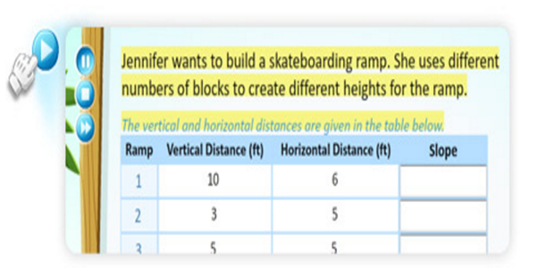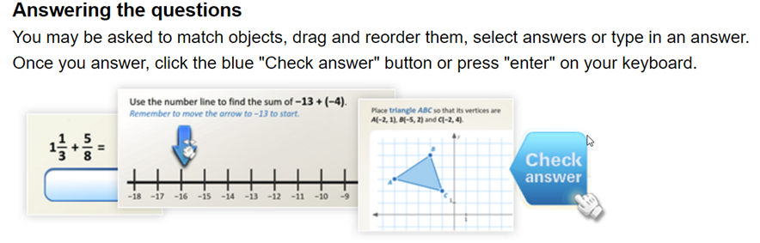
Figure 2. Check Answer Button Figure 3. Play Button to Read Question to Student
As can be seen in figure 2, Buzz Math gives students the option to read the question or have the question read to them. There is a blue arrow button to the upper-left of the screen for the student to click to have the question read aloud. This feature relates to the modality principle as discussed by Mayer (2014) stating that knowledge transfer performance is better when multimedia lessons with graphics include spoken text rather than printed text (Mayer, 2014, p. 332).
A feature of Buzz Math allows students to retry incorrect answers, as can be seen in figure 4 and figure 5.
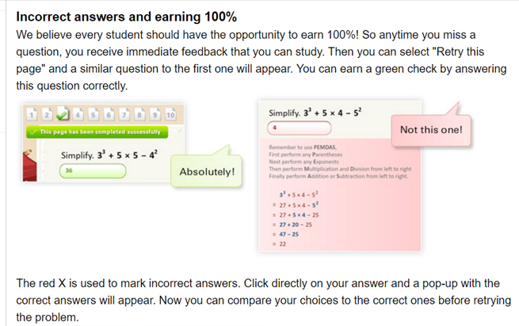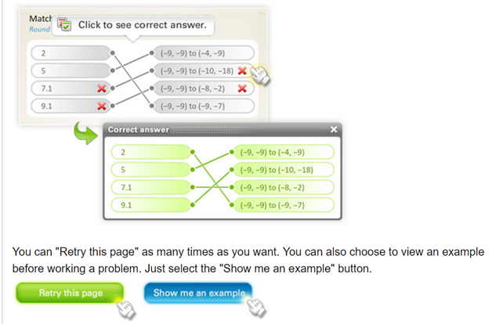
Figure 4. Hint to Retry Question Figure 5. Retry Question with Help
As stated by Mayer (2014), cognitive processing for meaningful learning occurs within working memory (p. 318). By allowing students to repeat these attempts within this activity until they are able to master the concept, the students are able to spend time and work on activating prior knowledge to correctly answer the question. This can also give the student more time to process knowledge to long-term memory. In schema processing, accretion would occur with the student simply remembering or understanding the event (Driscoll, 2005, p. 135), in this case the example, but in the case of repeated viewing (or those with prior knowledge, but confirming their understanding) tuning (the schema evolves to fit experience…from the example) occurs (Driscoll, 2005, p. 136).
I believe Buzz Math to be a good tool. It does a great job of using both the segmenting principle and the modality principle. The focus on presenting material in small segments and allowing the questions to be read to the student, can aid in more working-memory processing of concepts to long-term memory. Also, allowing students to repeat the questions without new values gives them the opportunity to activate prior knowledge to be successful with the new attempt. Also supported is schema acquisition and modification, specifically tuning. I am not sure if the pre-training principle is used since I do not have access to a live classroom. My son uses this tool in his class and alludes to some lecture material on concepts, such as definitions, before working on the Buzz Math activity in the classroom. Should students not complete the activity in class, they are allowed to finish as homework.
In summary, Buzz Math uses the segmenting and modality principles to prevent essential cognitive overload. It is a multimedia presentation that provides learners graphics and text. The activity presented is shown in short, segmented sections. Students are able to read the questions or have the questions read to them. Students can re-work incorrect questions allowing them more time to use working-memory processes. Educators can produce reports to help them understand where students can use pre-training for future work. Students are given a sense of success by the presentation of the “Bravo” at the end of the activity if they complete all questions correctly and the ability to receive more stars should they not complete all the questions but choose to continue working until they finish with one-hundred percent.
More recent research related to Mayer, shows that the modality principle is affected by environment and other parameters (Oberfoell, 2015), which I feel is consistent with the changes in access to technology experienced by younger learners. Researchers also discovered that the use of multimedia in emerging online environments, can be a distraction rather than a benefit. Buzz Math seems to address the middle between the research of Mayer and the newer research presented in Oberfoell. There seems to be many future research opportunities related to this topic. If asked to change this product, at this time I would not change the content. There is contrast change, between colors, that I would suggest along with sharper graphics.

References
Buzz Math. (n.d.). Help Center: Interface Guide. Retrieved February 12, 2017 from http://buzzmath-help.scolab.com/interface-guide/activity.
Buzz Math. (n.d.). Help Center: Teacher’s Quick Start Guide. Retrieved February 12, 2017 from http://buzzmath-help.scolab.com/teacher-s-quick-start-guide.
Buzz Math. (n.d.). Middle School Math Practice. Anytime, Anywhere. Retrieved February 12, 2017 from https://www.buzzmath.com/.
Driscoll, M. (2005). Psychology of Learning for Instruction (3rd ed.) (pp. 77-91). Boston, MA: Allyn and Bacon.
Driscoll, M. (2005). Meaningful learning and schema theory. Psychology of Learning for Instruction (3rd ed.) (pp. 111-152). Boston, MA: Allyn and Bacon.
Mayer, R.E. & Pilegard C. (2014) Principles for managing essential processing in multimedia learning: segmenting, pre-training, and modality principles. In R. E. Mayer (Ed.), The Cambridge Handbook of Multimedia Learning. (pp. 316-344). New York: Cambridge.
National Council of Teachers of Mathematics. (n.d.). Retrieved February 12, 2017 from http://www.nctm.org/.
Oberfoell, Amy Marie, "Understanding the role of the modality principle in multimedia learning environments" (2015). Graduate Theses and Dissertations. Paper 14602.

