Multimedia Product Critique Paper #2: Multimedia Photoshop
Tonya A. Melvin-Bryant
Coastal Carolina University

Multimedia Product Critique Paper #2: Multimedia Photoshop
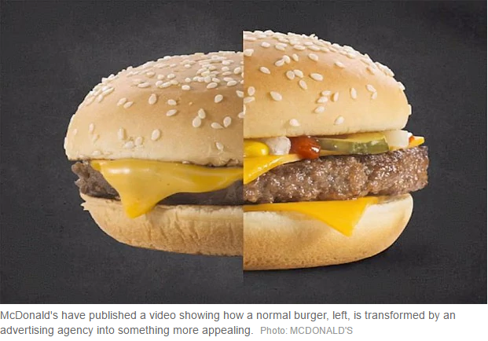
Hollywood and its drive for perfection forces the use of Photoshop on the world’s ear through magazine and social media coverage. This idea is driven by the need for everyday people to see celebrities without their flaws. This bug even caught up with McDonald’s, as you can see in a picture from The Telegraph (n.d.) in figure 1. On the right side of the image, the burger looks beefy and juicy with a soft bun, while on the other side, the bun looks dry and the beef looks flat and dry. As a researcher, I needed to understand how Photoshop played a role in learning how to design, develop, and present educational materials. In answering this question, I discovered CDTobie’s Photo Blog (https://cdtobie.wordpress.com/2015/11/20/what-photoshop-is-for-today/). Reading only a small portion of the material presented on this website helped in understanding the power of Photoshop to present well-designed photographic material, whether animation, real photos, or type, for educational purposes. So as a part of the requirement to learn Photoshop for my classes, I set out to review a variety of teaching multimedia on how to use Photoshop. This critique paper will review and provide a summary of a multimedia book, with CD, called The Web collection revealed: Adobe Flash CS4, Dreamweaver CS4, & Photoshop CS4. The collection is by Sherry Bishop, Jim Shuman, & Elizabeth Eisner Reding (Bishop, et al, 2010).
Figure 1 McDonald's and Photoshop Marketing
The book is a hard cover edition with separate sections for each Adobe tool (Flash, Dreamweaver, and Photoshop).
Each section is indexed with the topics covered for only that tool. There are color images and numbered lists steps along the edges of each page. The purpose of the book, according to the author(s), is to help readers gain practical experience with the tools as they work through step-by-step tutorials and learning projects. The author’s wrote the book because of Adobe’s newly released Creative Suite 4. Supposedly, this newest release integrated the work of developers and graphic designers in a way not seen before. In addition to providing individual learning lessons for each tool, the authors also provide an integrated section that shows the user how to move from one tool to another. They do so by building a website, using Dreamweaver, that uses both Flash and Photoshop. They tout the wonderful, full-color illustrations and user-friendly design of the lessons in aiding the learner to mastery of the newest Adobe applications.
Figure 2 Book cover
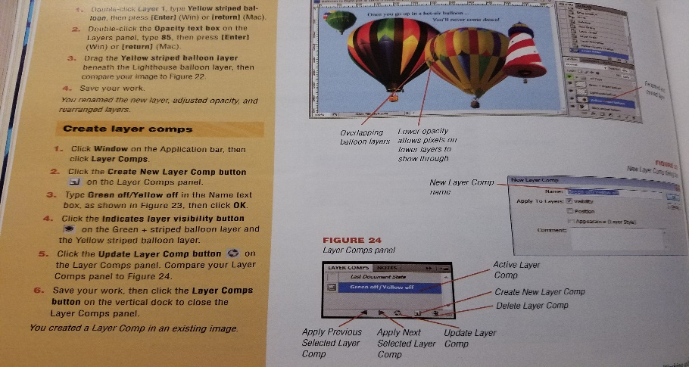
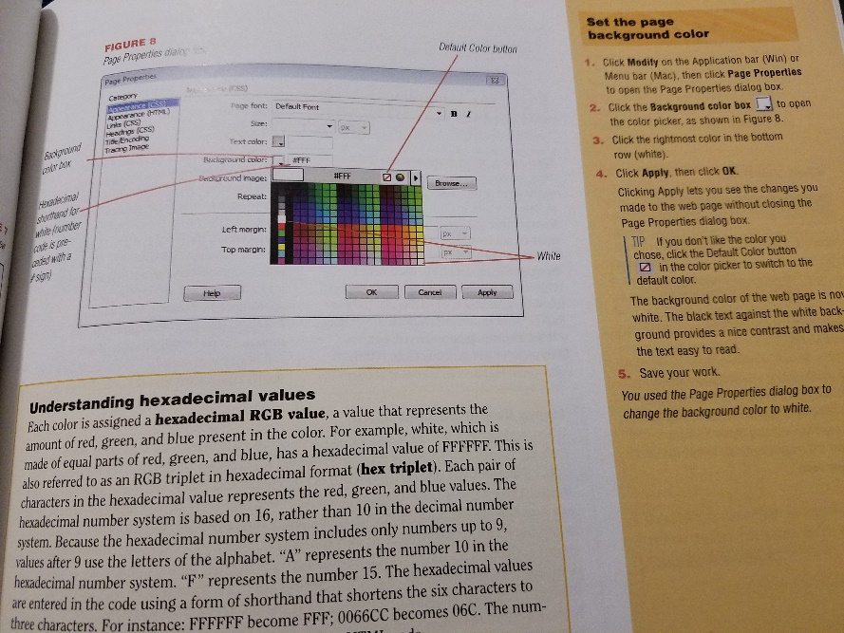
I do not agree with the authors in their description of their multimedia lesson set. Even with the lovely color illustrations, step-by-step guidance, and CD, this book does not follow many of the suggested principles from such researchers as Mayer (2014), Low and Sweller (1994, 2014), and Pilegard (2014). The book uses words and pictures to move learners through tutorials. This follows the multimedia principle that people learn better from words and pictures rather than words alone (Mayer 2014). However, the principle of split-attention is not followed as can be seen in figure 3. The instructions to complete a task are located on the side of the page while the image containing the screen is in the middle of the page. Also, there are lines pointing to various areas of the page, with the text also outside of the image.
Figure 3 Page breaking split-attention principle
Figure 4 Page with potential for prior-knowledge
This set of material is very early in the tutorial and leads to a question of whether students will need to activate prior knowledge to learn new concepts. Or would pre-training of the concepts of color settings and how to navigate windows be useful for the learners? Figure 4 show a pop-out box with information concerning hexadecimal values. This type of knowledge would serve the user better at the beginning of the tutorial, so the user has time to process the definition of color. A review at this point would act as prior-knowledge for the learner and help them process the new material better.
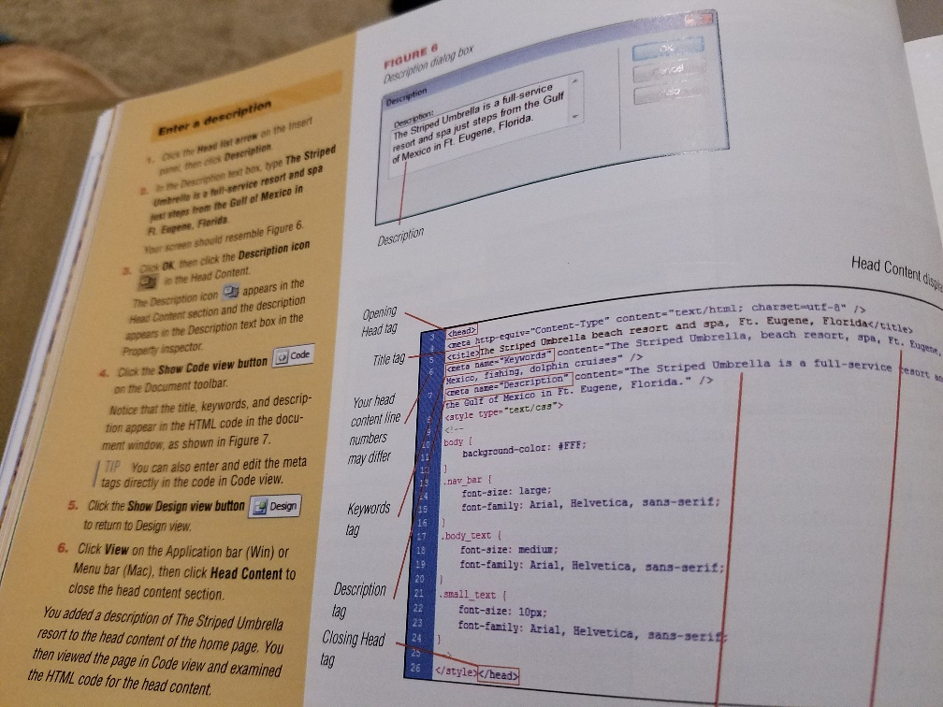
The modality principle is also not considered with this set of tutorials. Although there are many images, there is no narration provided. I tried the CD in hopes that it provided a lead into how to start with the tutorials, but after the home screen displayed, a page error also displayed. The only items available on the CD at this time are the student files for which to work on the tutorials. The principles that are mentioned so far target primarily novice learners. Although an expert learner may find this book easier to read and understand, the redundancy principle is not followed for these learners. This type of learner would not need both the set of instructions, the lines pointing into the image on the page, and the pop-outs. This learner could easily use refresher material just before the instructions and an image without the arrows. However, I have to think that the information shown in figure 5 is cognitive overload for both novice and expert learners. The authors added additional images in the instructions and content boxes in the main images, which describe content in the window. This would be a better fit for signaling, highlights, or other spacing.
Figure 5 Cognitive overload for all learners
The set of tutorials do follow the segmentation principle in that they provide the user opportunity to learn the material in smaller segments (Mayer and Pilegard, 2014). The tutorials do not allow for rote learning as mentioned in Driscoll and cited from Ausubel et al. (1978), because the learners will need to complete the tasks, show application, in order to build the product. Rote learning is simply memorization, but this tutorial shows the concept in context and even if the learner is low-knowledge, they are able to see the steps and commit the actions (Driscoll, 2005). However, extraneous cognitive overload can be increased should the user also attempt to use the actual software application, when first viewing the tutorial.
I believe the Web Collection Revealed tutorial set is not a good tool. It does a good job of using the basic multimedia principle and the segmenting principle; however, many other principles are ignored. The focus on presenting material in small segments can aid in more working-memory processing of concepts to long-term memory. An additional improvement would be to allow students to see a variety of scenarios to activate prior knowledge. Principles such as the modality principle, making use of the CD to present video or audio narration (or simply referring to an Internet area such as YouTube) and pre-training, providing complex terms early before the tutorial instructions, would improve the book considerably. Post-resource support, such as a glossary, would also improve the book. Schema acquisition and modification, specifically tuning is introduced with both pre-training and the post-resources.
Another area of consideration would be the redundancy principle. For expert users, the current tutorial layout increases cognitive overload by including so much extraneous text and symbols on the tutorial pages. A simple approach is to introduce the task for the novice on the left page and for the expert on the right page (removing the extra material). In summary, the Web collection’s set of tutorials are indeed a type of multimedia learning material (presenting graphics and text); however, the tutorials do not meet the goal of improving learner’s retention of concepts. The tutorials presented are shown in short, segmented sections. They do not prevent or reduce essential cognitive overload and educators could not use this as supporting text for a course and successfully meet their goals either.
If asked to change this product, I would likely choose not to use it at all. But if forced to make changes, I would immediately add video and/or audio content providing instructions on how to complete the variety of tasks in the collection. I would also develop an eBook with complementing content that would allow the user to click and see what happens when the task is actually performed. I would give the user opportunity to repeat a task using a different scenario, to see how things can change in the environment. I would site research to support many of these changes, such as that presented by Oberfoell (2015). Specifically, that the pool of younger technology users is outpacing older users and that many of these learners are in online or eLearning environments. Given that, the content and presentation of the material needs to be usable, useful, and user friendly. There cannot be distractions, that includes text and images, or this new generation of learners will not use the multimedia, but will find other ways to obtain the knowledge.

References
Bishop, S., Shuman, J., Reding, E.E. (2010). The Web collection revealed: Adobe Flash CS4, Dreamweaver CS4, & Photoshop CS4 [hard cover], Premium edition. Clifton Park, NY : Delmar Cengage Learning.
CDTobie’s Photo Blog (2015). Photo Technology, Photo Aesthetics. Retrieved March 15, 2017 from https://cdtobie.wordpress.com/2015/11/20/what-photoshop-is-for-today/.
Low, R., & Sweller, J. (2014). The modality principle in multimedia learning. In R. E. Mayer (Ed.), The Cambridge Handbook of Multimedia Learning. (pp. 227-246). New York: Cambridge.
Mayer, R. E. (2014) Introduction to multimedia learning. In R. E. Mayer (Ed.), The Cambridge Handbook of Multimedia Learning. (pp. 1-26). New York: Cambridge.
Mayer, R.E. & Pilegard C. (2014) Principles for managing essential processing in multimedia learning: segmenting, pre-training, and modality principles. In R. E. Mayer (Ed.), The Cambridge Handbook of Multimedia Learning. (pp. 316-344). New York: Cambridge.
Oberfoell, Amy Marie, "Understanding the role of the modality principle in multimedia learning environments" (2015). Graduate Theses and Dissertations. Paper 14602.
The Telegraph (n.d.). How McDonald’s uses Photoshop to touch up their menu burgers. Retrieved March 15, 2017 from http://www.telegraph.co.uk/finance/newsbysector/retailandconsumer/9345821/How-McDonalds-uses-Photoshop-to-touch-up-their-menu-burgers.html.

